**STROKE PREDICTION USING MACHINE LEARNING**

R.Bhavana,B.Ganesh Babu,P.Ravi kiran

Student,Department of Computer Science and Engineering, CMR Technical Campus, Medchal, Hyderabad, Telangana, India

Mrs.Anusha Reddy

Assistant Professor, Department of Computer Science and Engineering, CMR Technical Campus, Medchal, Hyderabad, Telangana, India

[177r1a05m5@gmail.com](mailto:177r1a05m5@gmail.com)

[177r1a05m4@gmail.com](mailto:177r1a05m4@gmail.com)

[177r1a05j8@gmail.com](mailto:177r1a05j8@gmail.com)

**ABSTRACT**

***Stroke is a drawn out inability sickness caused everywhere on the world and it is the third driving reason for demise. Early forecast of stroke gives more important to the current time. Stroke happens fundamentally due to individuals' way of life in the advanced time changing elements, for example, high glucose, coronary illness, weight, diabetes. In this examination, we analyze the Support vector machine, Decision tree, Random forest and XG Boost.we have utilized four AI calculations to recognize the sort of stroke that can happen or happened to structure an individual's actual state and clinical report information. We have gathered a decent number of sections from the clinics and use them to take care of our concern. The characterization result shows that the outcome is good and can be utilized continuously clinical report. We accept that AI calculations can help better comprehension of illnesses and can be a decent medical care buddy.***

**I.INTRODUCTION**

AI, a subfield of Artificial Intelligence including the improvement of computations that sort out some way to make conjectures subject to data, has different rising applications in the field of bioinformatics.Bioinformatics oversees computational and mathematical philosophies for appreciation and dealing with regular information. Preceding the advancement of AI computations, bioinformatics estimations should be explicitly tweaked by hand, for instance, protein structure assumption, exhibits extremely problematic. AI strategies, for instance, significant learning engage the estimation to use customized incorporate acknowledging which suggests that reliant upon the dataset alone, the computation can sort out some way to combine various features of the data into an progressively unique course of action of features from which to lead further learning. This complex approach to manage learning plans in the data allows such systems to make exceptionally mind boggling gauges when arranged on tremendous datasets. Lately, the size and number of available characteristic datasets have take off, enabling bioinformatics experts to use these Machine learning systems. AI has been applied to six regular spaces. AI methodologies for assessment of neuro imaging data are used to help investigate stroke. Analysis and treatment of stroke sickness are exceptionally unpredictable, non-industrial countries, because of the shortfall of symptomatic gadgets also as a lack of specialists and numerous different assets that influence satisfactory forecast and drug of heart patients. As of late, PC innovation and AI strategies are presence with this worry, to improve the framework to help specialists in the starter stage in settling on choices about disease.

**2.EXISTING SYSTEMS AND DRAWBACKS**

Numerous framework have been created lately to for stroke expectations as of late all varying by little factors. Choice tree is utilized to choose structure the given condition on each stage. Head segment investigation is accomplished to chip away at easier measurement. In creators expressed that in light of the expansion of the strokes there are numerous sudden passing these days. We can foresee the manifestations of stroke through clinical information investigation. These clinical information will be broke down by the Nao Robots that will give us a computerized approach and furthermore empowers advanced mechanics ongoing connection with human body. In review that there are so numerous online wellbeing recordings that guide individuals about different sickness. Then again we came to realize that these and near outcomes were an improvement in the quality, exactness and ability of the film recommender when contrasted with conventional methodologies. Data about illnesses are definitely not right. These will make negative feelings on the patients wellbeing that will build the patients, circulatory strain which will bring about stroke. Taking care of such patients starts with appropriate data about every single part of stroke indications and fix. For this we need early recognition of stroke what's more, stroke restoration naturally. Thus, we will make a stroke extraction video that will assist the patients with being appropriately mindful of the manifestations of stroke. The video object extraction incorporates division measure that helps in future stroke forecast. Division is utilized to boost the forecast cycle of recuperating and recovery of stroke patients in ensuing investigations. This examination employments a minor stroke removed video object utilizing LVQ which has been altered. In creators proposed

that electronic clinical case is utilized for higher exactness and precision to foresee the illness. Electronic clinical case is an information base on which different prescient calculation is applied to give aftereffects of higher exactness.

**4.PROPOSED WORK**

At first dataset is preprocessed to eliminate missing qualities, at that point information is taken care of to AI calculations and yield is estimated. Stroke forecast dataset has credits like sexual orientation, age, hyper- strain, coronary illness, BMI, glucose level, smoking propensities. The information is separated 80:20 for preparing and testing of the model. Especially, they considered the customary issues of assumption in a clinical dataset, feature decision, and data attribution. This investigation proposes the use of a inventive computation for customized feature decision - what picks fiery features reliant upon heuristic: preservationist mean. This computation was applied in a blend in with Support Vector Machines (SVMs). The component assurance computation achieves a more essential zone under the ROC twist (AUC) in assessment with the Cox relative perils model and L1 regularized Cox model. The methodology was moreover applied to the clinical assumption for various sicknesses - where missing data is ordinary, and danger factors are not surely known.

**3.PROJECT ARCHITECTURE**

Framework is the model that portrays the development, lead and more viewpoints on the system. It contains structure parts and the system made that will coordinate to do the overall system. In the Machine learning plan , the unrefined data goes through various methods preceding giving the yield. The whole data is screened and anomalies and indistinct data is wiped out from the enlightening record achieving the yield with complete exactness.

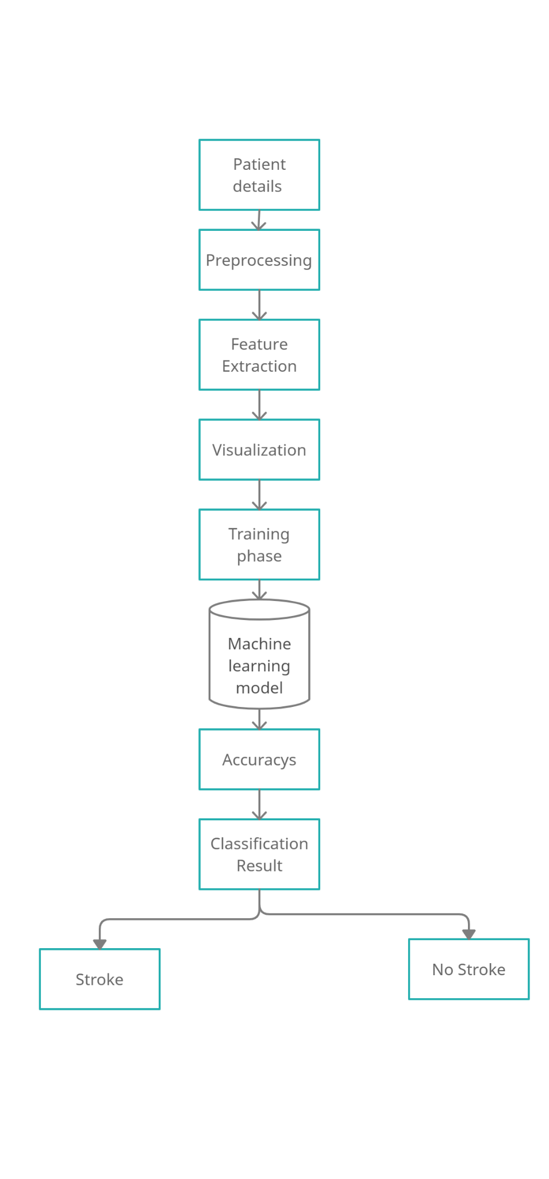

Fig 1-Project architecture

**5.SUPPORT VECTOR ALGORITHM**

In Machine Learning, support-vector machines (SVMs, furthermore support-vector organizations) are figured out how to learn models with related learning computations that separate data used for portrayal and backslide examination. A SVM model is a depiction of the models as centers in space, planned with the objective that the examples of the various arrangements are segregated by an undeniable opening that is pretty much as wide as could sensibly be anticipated. Exactly when data is unlabelled, regulated learning is past the domain of imagination, and an independent learning approach is required, which attempts to find trademark batching of the data to social occasions, and a short time later guide new data to these outlined get-togethers.

SVM streamlining issue is an instance of obliged advancement issue, and it is constantly liked to utilize double enhancement calculation to take care of such compelled improvement issue. That is the reason we don't utilize angle drop. Since it is compelled enhancement issue Lagrange multipliers are utilized to settle it, which is depicted underneath, It appears as though , will be more numerical yet it isn't, its only couple of steps of discovering angle. We will partition the total detailing into three sections.

1.In first we will define SVM enhancement issue Mathematically

2.we will discover slope regarding learning boundaries.

3.we will discover the worth of boundaries which limits ||w||

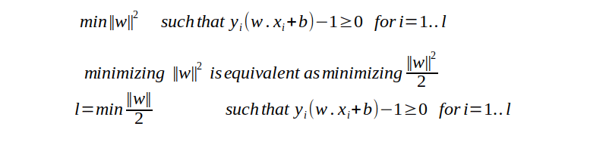

Fig 2 Problem formulation

The above condition is Primal enhancement problem.Lagrange technique is needed to change over compelled streamlining issue into unconstrained improvement issue. The objective of above condition to ge the ideal incentive for w and b

. 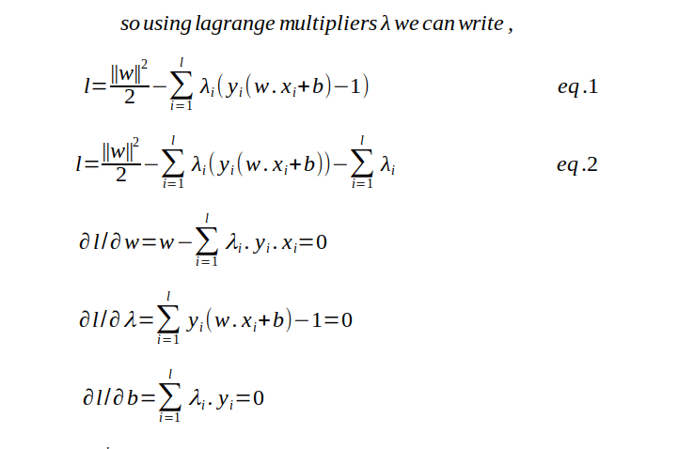

Fig 3- discovering the angle as for w ,b and lambda.

May be above condition is looking interesting? in any case, it isn't, its simply secondary school math of finding minima regarding variable.

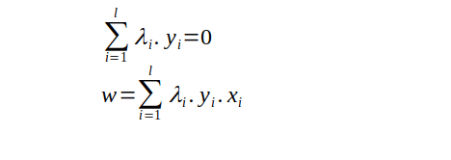

Fig 4— we will get the worth of w

As,from the above detailing we simply ready to track down the ideal worth of w and that is to reliant upon λ, so we need to track down the ideal worth of λ too. Furthermore, discovering ideal worth of b needs both w and λ. So discovering the worth of λ will be the significant for us.

**6.RANDOM FOREST ALGORITHM**

Similarly as a group should have different people to be insightful, an irregular timberland should be made out of assorted choice trees to be compelling.

There are two different ways that the irregular backwoods calculation empowers this variety.

In the first place, every choice tree inside an irregular timberland is prepared on an alternate subset of the information. This is made conceivable by a testing cycle known as "irregular examining with substitution", where records are chosen indiscriminately yet not eliminated from the underlying dataset. By plan, this supports copies in the preparation datasets for each tree. Since this interaction is rehashed, every choice tree "knows" an alternate subset of the information.

The arbitrary woodland calculation likewise makes variety by choosing an irregular subset of the full rundown of highlights at each split in every choice tree. The size of that subset is an adaptable boundary, however a typical decision is to utilize the square base of the complete number of highlights (this is the thing that the scikit-learn execution of the irregular woods classifier utilizes of course).

For instance, suppose we were preparing an irregular woodland with three choice trees and ten highlights.

At the root (first) hub of the principal choice tree, the calculation would choose three highlights aimlessly (square foundation of 10 is 3.2). It would then track down the most ideal split, and again pick three arbitrary highlights to assess the following split. This is rehashed for each split in every one of the trees.

Eventually, this interaction creates trees that have been presented to various data, which are then collected together to make a last expectation.

For a relapse issue, the arbitrary woodland takes the normal of each tree's forecast. For a grouping, it takes the mode or larger part.

**7. DECISION TREE ALGORITHM**:

Decision tree learning is one of the insightful showing approaches used in estimations, data mining, and Machine Learning. It uses a decision tree (as an insightful model) to go from discernments about a thing (addressed in the branches) to choices about the thing's goal worth (talked to in the leaves). Tree models where the target variable can take a discrete course of action of characteristics are ca

lled portrayal trees; in these tree structures, leaves address class names, and branches address conjunctions of features that lead to those class names. Decision trees where the goal variable can take consistent characteristics (routinely authentic numbers) are called backslide treesThere are numerous calculations written to fabricate a choice tree, which can be utilized by the issue attributes you are attempting to settle. Relapse trees are utilized when subordinate variable is persistent and Classification trees are utilized when subordinate variable is straight out.

Not many of the regularly utilized calculations are recorded underneath:

ID3

C4.5

Truck

CHAID (Chi-squared Automatic Interaction Detector)

Despite the fact that the techniques are diverse for various choice tree building calculations however every one of them work on the rule of Greediness. Calculations attempt to look for a variable which gives the greatest data gain or partitions the information in the most homogeneous manner.

There are numerous measurements utilized by choice trees to discover the best split factors.

**Entropy**

A choice tree is assembled hierarchical from a root hub and includes parceling the information into subsets that contain occasions with comparative qualities (homogeneous). ID3 calculation utilizes entropy to ascertain the homogeneity of an example. On the off chance that the example is totally homogeneous the entropy is zero and if the example is similarly isolated it has entropy of one.

Numerically,



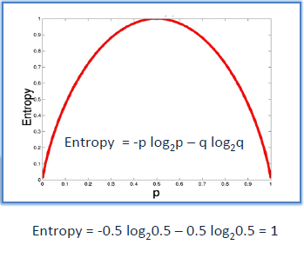

**Information Gain**

Entropy gives proportion of pollutant in a hub. In a choice tree building measure, two significant choices are to be made — what is the best split(s) and which is the best factor to part a hub.

Information Gain rules helps in settling on these choices. Utilizing a free factor value(s), the youngster hubs are made. We need to figure Entropy of Parent and Child Nodes for ascertaining the data acquire because of the split. A variable with most noteworthy data acquire is chosen for the split.

**8.NAIVE BAYES CLASSIFICATION**

Directed learning calculation utilizes the Naïve Bayes Model, which relies upon Bayes hypothesis includes settling the various divisions of the blunders. Among various sorts of Naive Bayes systems, we carry out "Gaussian credulous Bayes" in this examination work. The probabilities of the patients affected by hemorrhagic and ischemic strokes can be composed as:

P(AB)=∑w∈A∩BP(WB)+∑w∈A∩BcP(WB) (1)

=∑w∈A∩BP(w)P(B) (2)

=P(A∩B)P(B) (3)

where, 'A' is likelihood of getting stroke and 'B' characterizes most noteworthy happening worth of each essential characteristic in dataset.

The occasions addressed by arrangement vector x = (x1, x2, x3,… … ,xn) and P(Ck | x1, x2, x3,… … ,xn ), where, 'Ck' characterizes the 'kth' class and 'k' is the quantity of classes.

The contingent likelihood of Gaussian Naïve Bayes can be disintegrated as follows:

P(Ck∣x)=P(Ck)P(x∣Ck)P(x) (4)

Utilizing the likelihood on development a model classifier is determined as:

y^=argmax{P(c1)∏ni=1P(xiC1),P(c2)∏ni=1P(xiC2)} (5)

where, 'n' characterizes number of essential boundaries (n=9), 'C1' characterizes the generally safe and 'C2' characterizes the high danger.

**9.RESULTS**

This project predicts the percentage of a patient from a dataset depending on the various factors and his lifestyle using various machine learning algorithms like random forest,support vector machine and so on.

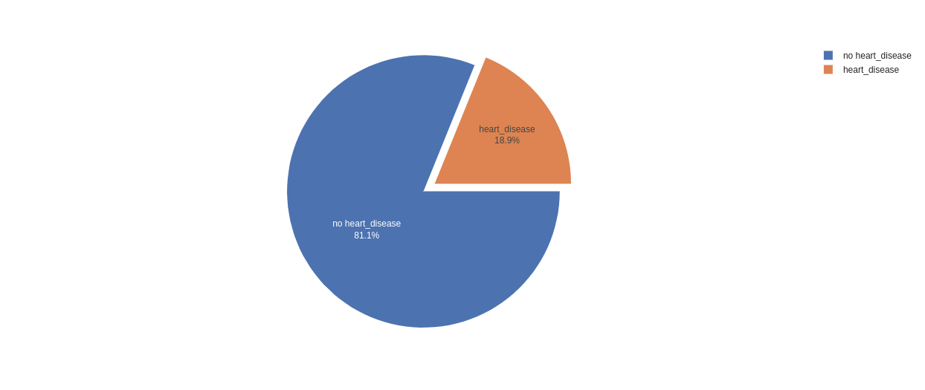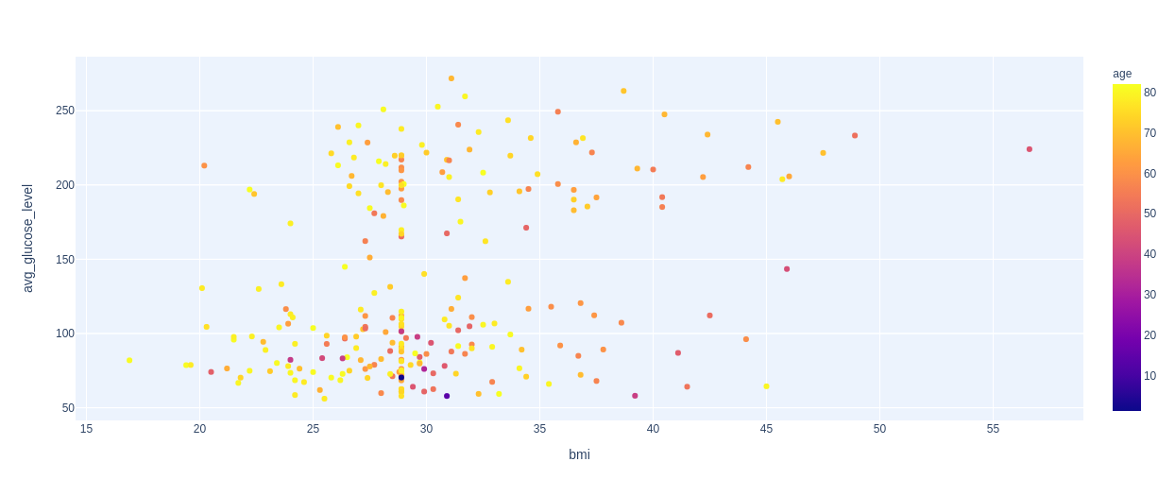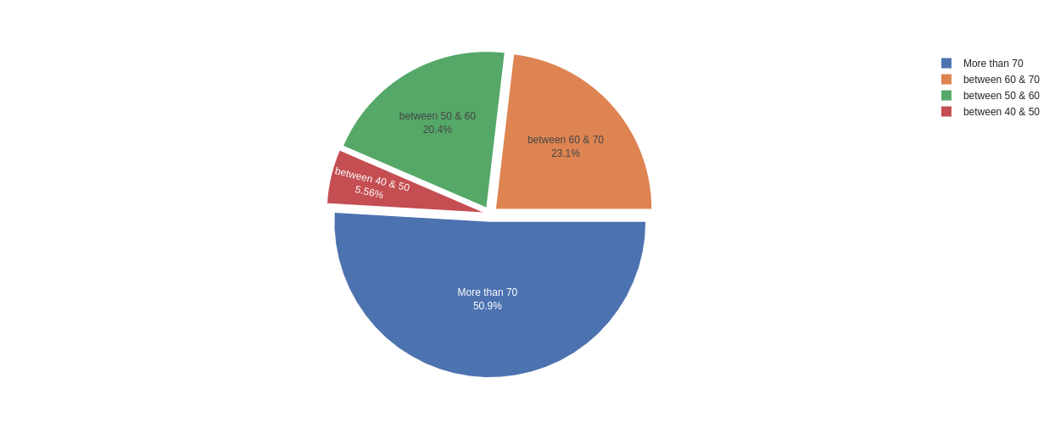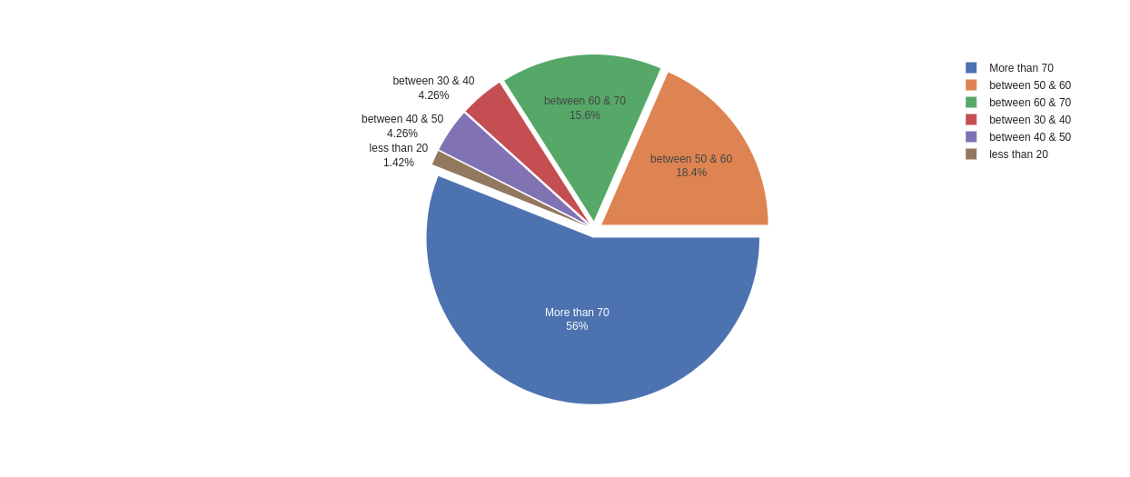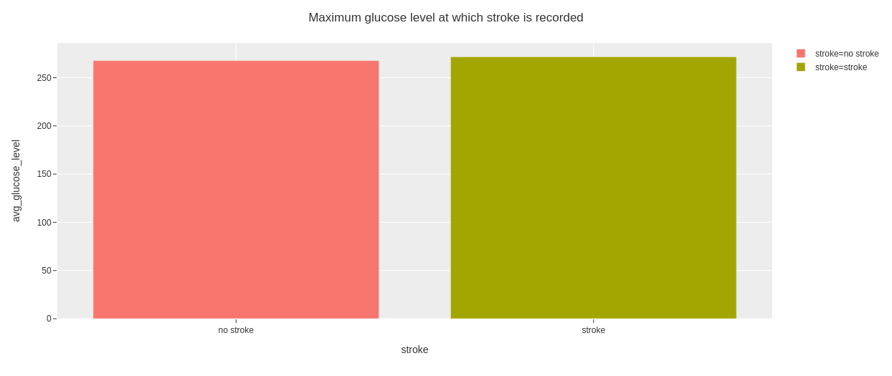

**10.CONCLUSION**

The stroke forecast utilizing AI strategy can be utilized to discover whether the patient having stroke or not. The expectation gives the precise consequence of 97% in help vector machine. By utilizing this strategy we can ready to anticipate the stroke of the patient and give the best treatment before it becomes basic.

**ACKNOWLEDGEMENT**

The author would acknowledge the support of Chairman,Director and Head of Department,Department of Computer Sciences,CMR Technical Campus,Medchal,Hyderabad,Telangana for their encouragement to the authors.

**REFERENCES**

**1.**[**https://medium.com/greyatom/decision-tree-intuition-a38669005cb7**](https://medium.com/greyatom/decision-tree-intuition-a38669005cb7)

**2.**[**https://towardsdatascience.com/an-intuitive-explanation-of-random-forests-109b04bca343**](https://towardsdatascience.com/an-intuitive-explanation-of-random-forests-109b04bca343)

**3.**[**https://medium.com/@ankitnitjsr13/math-behind-support-vector-machine-svm-5e7376d0ee4d**](https://medium.com/@ankitnitjsr13/math-behind-support-vector-machine-svm-5e7376d0ee4d)

**4.**[**https://medium.datadriveninvestor.com/understanding-machine-learning-algorithms-knn-812840e3e284**](https://medium.datadriveninvestor.com/understanding-machine-learning-algorithms-knn-812840e3e284)